Visvesvaraya Technological University, Belagavi – 590018



**Seminar Report on**

# Medical Applications of Virtual Reality

Submitted in partial fulfillment of requirement for the award of the degree

# BACHELOR OF ENGINEERING

in

# Computer Science and Engineering

Submitted by

Rhea Benedicta D’souza

4SO18CS097

Under the guidance of

Ms Renuka Tantry Ms Supriya Salian

Assistant Professor Assistant Professor SEMINAR GUIDE SEMINAR COORDINATOR



# DEPARTMENT OF COMPUTER SCIENCE AND ENGINEERING ST JOSEPH ENGINEERING COLLEGE

**Vamanjoor, Mangaluru - 575 028**

**2021-2022**

# ABSTRACT

Virtual Reality (VR) is one computer-generated system that creates the spectator the sensation of being entirely engrossed in their surroundings. A Virtual Reality headset is used to experience this reality. Virtual Reality was once thought to be on the horizon but continued to stay a science fiction until recently. Virtual Reality is now being used in a multitude of areas of our lives, including everything from video games to different industrial uses, and, of course, medical applications. Despite knowing that Virtual Reality has been around for decades, many people are skeptical of it. Virtual Reality as well as Augmented Reality are commonly used interchangeably. The primary distinction is that VR generates a virtual environment in which we may immerse ourselves using a headset. Everything we perceive is a product of an artificially constructed environment based on images, sounds, and other media. In augmented reality (AR), on the other hand, our surroundings serve as the framework into which objects, images, and other material are integrated.

This presentation focuses on the medical applications of virtual reality, including a general overview of its operation and benefits in the medical profession. Robotic surgery, phobia therapy, surgical simulation, and skills training are just a few of the applications of virtual reality in healthcare. The introduction of the Oculus Rift and HTC vive has increased the use of virtual reality in a variety of businesses. Medical Education, as a training tool for physicians and students, is one of the most important applications of virtual reality in medicine. Virtual reality is being utilised as an effective diagnostic tool to assist doctors and physicians in making correct diagnosis. Because it is a low-cost, flexible, and low-risk alternative, it is also used to treat mental illnesses. VR can also help with anxiety and panic episodes by teaching new ways for keeping the body relaxed and calm. Therapy, Physical Fitness, and Pain Management Virtual Reality in Surgery, Autism Treatment with VR, VR for the Disabled, and more incredible uses of the technology.

Above are some of the ways virtual reality is fast revolutionising the healthcare field and will undoubtedly play a significant part in our lives in the next years, changing the way we live entirely. Virtual reality is a technology that has the potential to revolutionise every sector, including healthcare, space, construction, and tourism. This technology will become exceedingly strong very soon as the metaverse develops. Medical virtual reality has many intriguing prospects. Clinical researchers and real-life medical professionals are equally enthusiastic about this technology as gamers. Every day, healthcare practitioners discover new methods to make people's lives better. It's interesting to see how a technology like this may be so beneficial in the medical area. We must continue to create innovative technology to benefit society.

# TABLE OF CONTENTS

|  |  |
| --- | --- |
| **SL NO. TITLE** | **PAGE NO.** |
| 1 Introduction | 1 |
| 2 Working  2.1 Virtual reality headset  2.2 Basic components of VR headset  3 Types of VR headsets | 2 |
| 4 Applications | 9 |
| 4.1 Virtual Reality for medical  training  4.2 Virtual Reality for Surgery  4.3 Phobia Treatment  4.4 Teaching Empathy  4.5 Pain Management Therapy | 9 |
| 5 Conclusion | 11 |
| 6 References | 12 |

# FIGURE INDEX

|  |  |
| --- | --- |
| **FIGURE NO. TITLE** | **PAGE NO.** |
| Figure 1 The Sensorama  Figure 2 History of VR  Figure 3 VR headset  Figure 4 VR lenses  Figure 5 VR controller  Figure 6 From left to right: Oculus Rift,  HTC VIVE Pro, Lenovo  Explorer, Samsung Odyssey  Figure 7 From left to right: Lenovo Mirage  Solo, HTC VIVE Focus, Pico  Neo, Oculus Go  Figure 8 From left to right: Samsung Gear  VR, Google Daydream view 2,  Xiomi Mi VR Play 2, Google Cardboard  Figure 9 Samsung 360 camera  Figure 10 Knee surgery using VR  Figure 11 VR phobia treatment environment  Figure 12 Using VR to treat fear of heights  Figure 13 Using VR to treat fear of spiders  Figure 14 Using VR to teach empathy  Figure 15 VR application to teach  Empathy to medical students  Figure 16 Different tasks of the application  Figure 17 Universal pain assessment tool  Figure 18 Robot-arms holding VR goggles  Figure 19 Before and after VR | 1  1 |

1. **INTRODUCTION**

Morton Heiling, a cinematographer, invented the Sensorama as a multimedia device in 1957. In a theatre cabinet, it was a multimedia gadget that allowed viewers to interact with it. A display screen for sight, oscillating fans for touch, fragrance-generating equipment, and audio speakers for sound were used to stimulate the customers' senses. Following this, in the 1960s and 1970s, different devices based on this technology were created, leading to Jaron Lanier, a computer scientist, researcher, and artist, coining the phrase "virtual reality," which has since become society's marvel. With Tom Zimmerman, he co-founded the Visual Programming Lab (VPL) and co-developed the Dataglove and EyePhone HMD, making VPL the first firm to sell VR glasses.

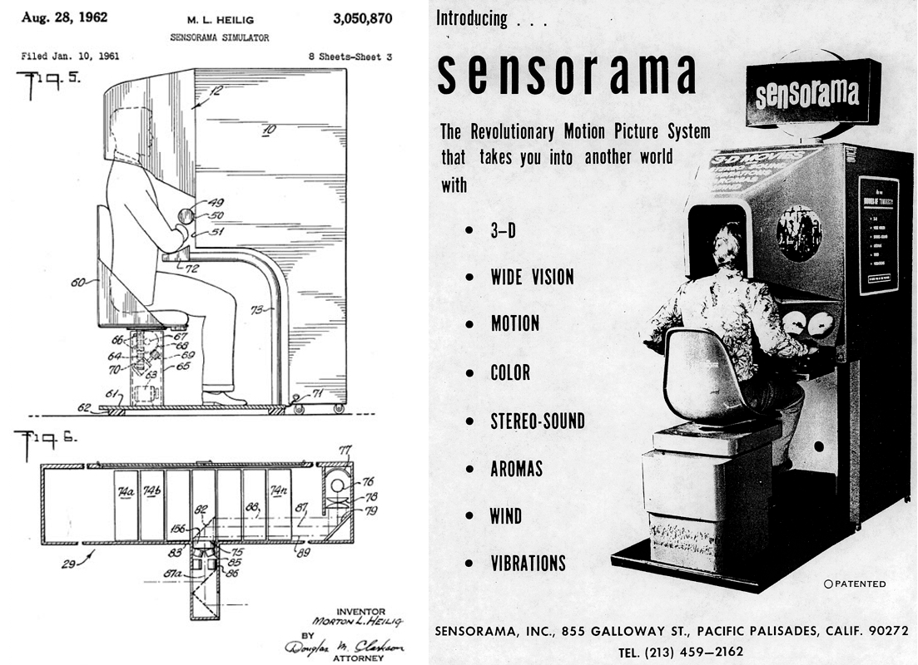

**Figure 1: The Sensorama**

The earliest virtual reality headsets were created in the 1960s. Nearly 30 years after the concept was first imagined, Ivann Sutherland created the first VR helmet for military usage. The first VR headsets were developed with military software and a motion control platform for use in training exercises. The military is increasingly using virtual reality training tools to prepare for flying exercises, combat situations, and other scenarios. An immersive experience is required to test military personnel and prepare them in a safe training environment before they enter the field. Virtual Reality is being used in a multitude of areas of our life, from video games to numerous industrial uses, and it is even being used in medical. In 1965, Robert Mann created the first virtual medical system to create a new educational environment for reconstructive surgery. In the late 1980s, the head-mounted display (HMD) was introduced as a wearable device for VR depictions in medical. Some of the first pioneering applications such as medical education were entirely predicated on hands-on procedures more than a decade later. In the 1990s, several detrimental effects of VR usage were found. After only 20 minutes of use, users felt nausea, dizziness, temporarily reduced vision, and a lack of sense of presence. The negative effects were attributed to technical problems such as lag time and the human eye's inability to focus in-depth on "artificially distant" 3D things.

**Figure 2: History of VR**

Since 2012, there has been an amazing rise in interest and buzz surrounding mass market virtual reality (VR) because to helmet mounted display (HMD) innovations in development such as the Oculus Rift, HTC Vive, Gear VR, and Google Cardboard. Virtual simulation technologies have advanced way since the Sensorama Simulation model in 1962.

For decades, virtual reality and simulation innovation have been employed in healthcare teaching and training. Hospitals have invested a lot of money on surgery simulators since they have shown to be quite beneficial for physician training. Virtual reality in health coverage is still in its early phases in aspects of breakthrough therapeutic paradigms and widespread clinical uptake and use. Clinical efficacy evidence from well-designed and controlled human trials will be scrutinised more rigorously by this sector's innovators. Things will become extremely fascinating in the (not-too-distant) future with the seamless integration and confluence of breakthroughs like VR with artificial intelligence, deep learning, big data analytics, wearables, bio-feedback, and rising computing power. Virtual simulation models that comprehend as a patient intertwines with them will transform balkanized patient-centered care and change the way healthcare is delivered.

# WORKING

Virtual reality is rather a technique that creates a three-dimensional world in which a person seems to be submerged while browsing or contemplating it. The user has complete control over the 3D world while in it. The user develops 3D VR worlds on though one hand, and then experiences or explores them using suitable equipment including such VR headsets on the other. Controlling and inspecting material is possible with some devices, such as controllers. Making the material starts with a basic understanding of computer vision, a method that allows phones and laptops to interpret photos and videos similarly to a person's visual receptors. Virtual Reality is a very immersive experience that may be safely experienced while emulating something real. You can use a Virtual Reality headset or a suitable application to engage customised simulations. These simulations are meant to be completely immersive experiences that the user may engage with and investigate. The spectator has total control over the scene, including the ability to look about and interact with the items. Virtual Reality is most typically employed in computer-generated simulations where a whole 3-D environment is recreated as realistically as possible. A user may then interact with the scene and control the environment using a variety of electrical devices.

A headset, on the other hand, is required for a really immersive VR experience. A virtual reality headset (VR headset) is a head-mounted display (HMD) that blocks out the outside world and displays a three-dimensional world or a series of interconnected pictures to form a simulation. Virtual reality headsets isolate us from the outside world and provide a unique viewpoint. The screen is frequently set to focus, filling our whole peripheral view and blocking out the outside world. When you put on a high series VR headset, you should feel as though you are in the scenario and engaging with it.

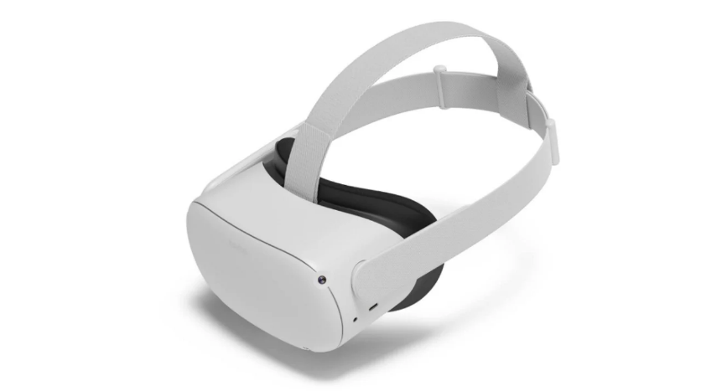

**Figure 3: VR headset**

The first step in starting a VR simulation is to put on this headset. On a PC or console, users often launch the programme themselves or have it started for them. The user may switch their view to the VR headset after plugging it in to completely immerse themselves in the experience. The user may navigate around the scene using the motion controls or their own body movement after the headset has been mounted to their head and calibrated to fill their peripheral vision. When the user looks around, the scene pans across the screen thanks to motion controls in the headset. VR technology continues to increase immersion. Virtual reality headsets like the Oculus Rift or rather Samsung Gear VR are now widely accessible and can be used in almost every home. The Oculus Rift is one of the most powerful home VR systems available, whereas this Samsung Gear VR works with both the latest Samsung Galaxy smartphones to turn any smartphone screen into a virtual reality perception. As more competitors manufacture items, that will be interesting to notice how the business progresses and what sorts of products are supplied to customers in the future.

Virtual reality systems prioritise immersion and engagement. Virtual reality systems aim to entirely engulf the user in a new virtual environment. This entails utilising the visor to overlay their peripheral vision, wearing reverberant headphones to submerge them in the environment, and allowing them to modify the scene using head gestures. Introducing these three measure of access might, at the very least, provide an immersive experience. It can make a big difference to have more interaction possibilities. App developers strive to provide more immersive experiences in a variety of films and games. Through the use of a specialised controller, users may engage with both the scene and control sections of the forthcoming Playstation VR.

***2.1 Virtual Reality Headset***

Virtual reality headsets are intended to create life-size, three-dimensional virtual environments that are not constrained by the limitations of screen-based media. Video is transferred to the headgear via HDMI cable in the context of the Oculus Rift and HTC's Vive, but videos are already on the smartphone in the case of Google Cardboard and Samsung's Gear VR. A single or two feeds can be ligated to one or two LCD displays in VR headsets, one for each eye. The gadgets are sometimes appealed to as goggles because they include an ensemble of lenses that sit between the viewfinder and the pixels. The lenses may be adjusted in certain circumstances to match the path length between both the eyes, which varies from another user to the next. The lenses will focus and distort each eye's vision before merging the two 2D images to create a stereoscopic 3D image that shows how each eye views the surroundings. Virtual reality headsets boost assimilation by expanding the field of view, or the apparent size of a picture. Since an 360-degree display isn't always possible, most high-end Gadgets rely on a 100- or 110-degree field of vision, which is usually enough to get the desired effects. VR headsets require a minimum frame rate of 60 frames per second for the final images to be generated realistically sans having to shut down or making users sick.

***2.2 Basic Components of VR Headset***

a) An array of sensors:

Unlike 2D television, virtual reality is not a passive experience. Users engage with virtual environments that change in response to their continual input. To do this, VR headsets are fitted with a range of sensors, including a six degrees of freedom (6DoF) head tracking system in some cases. Using gyroscopes, accelerometers, and other sensors, a 6DoF system detects head motions and repositions the display. Eye-tracking sensors are included in certain headsets, which identify when the user's gaze is directed to a virtual item or place.

b) Lenses and screens:

The lenses and displays make up the majority of the VR headset's hardware. Stereoscopic lenses sit between the screen and your eyes, distorting the image to make it look three-dimensional. The lens transmits two pictures, one for each eye, replicating how human eyes receive and interpret sights in the real world. Furthermore, graphics in VR headsets appear to move side to side to imitate a 360-degree experience, which is achieved by slowly altering visual information in line with head tracking data.

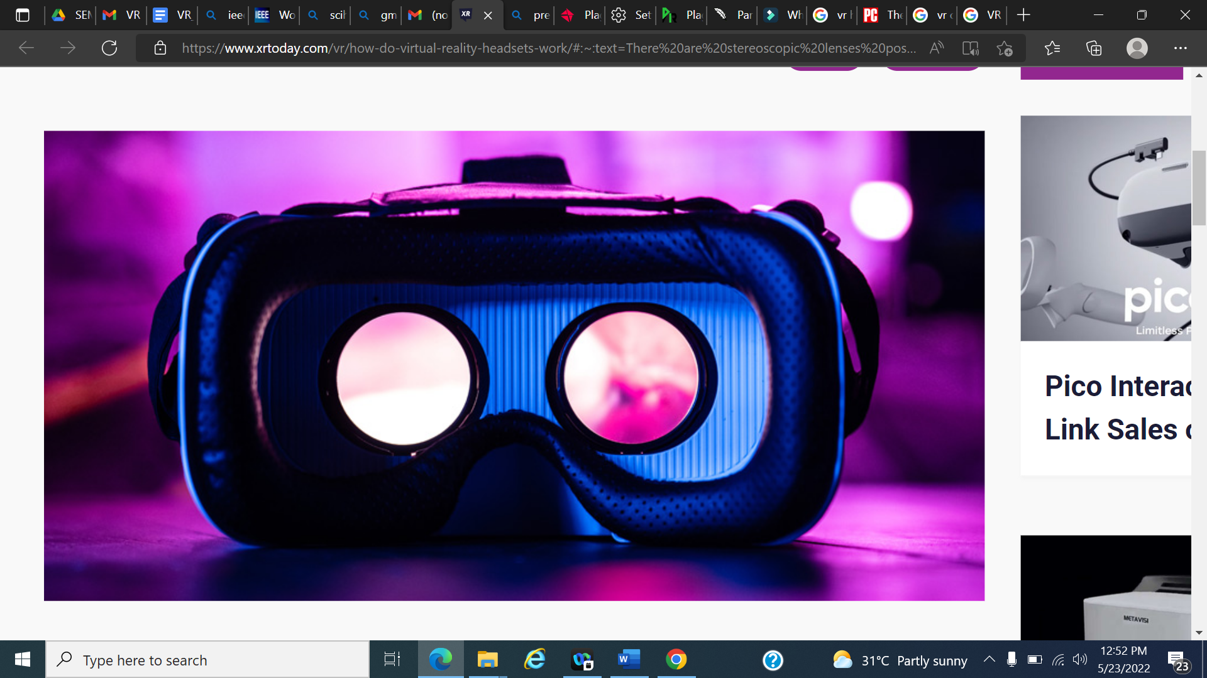

**Figure 4: VR lenses**

c) Immersive audio:

The lenses and displays make up the majority of the VR headset's hardware. Stereoscopic lenses sit between the screen and your eyes, distorting the image to make it look three-dimensional.

The lens transmits two pictures, one for each eye, replicating how human eyes receive and interpret sights in the real world. Furthermore, graphics in VR headsets appear to move side to side to imitate a 360-degree experience, which is achieved by slowly altering visual information in line with head tracking data.

d) Controllers:

Finally, virtual reality headset controllers connect the actual and virtual worlds. There are a variety of controllers available, in addition to the conventional set of two portable controllers that come with most headsets. Samsung's Gear VR package, for example, contains a single-handed motion controller, but HTC VIVE combines single-handed joystick-like controllers with a docking station. Meta is believed to be developing a set of haptic-based controllers for pressure-sensitive touch and navigation. Valve Index also has a one-of-a-kind controller that uses fist clutching.

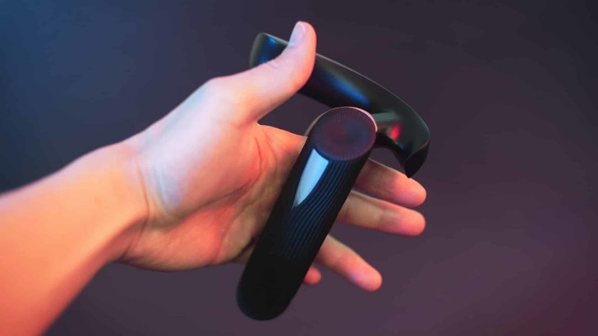

**Figure 5: VR controller**

All of these components, as well as specialised VR software, are required for the headset to work properly. When the headgear is switched on, users are met by a lifelike virtual environment that functions as a lobby and looks similar to a computer's homepage. This environment allows users to download programmes, talk with other virtual people, modify settings, upgrade devices, and do other tasks. Pictures are broadcast from a video source such as a smartphone, PC, or, more commonly, the cloud, in modern headsets. The lens splits the video image into two halves and calibrates them into a stereoscopic 3D image on the screen. Built-in sensors change the surroundings gradually as you look around, adjust your gaze, or raise your hands. Apart from this basic capacity, VR headsets are fairly powerful. There are productivity apps that allow you to design things in virtual reality and then export them as 3D files to the cloud, for example. Advanced VR headsets employ a rapid screen refresh rate to produce and update content instantaneously.

Key features that characterize a good VR headset are as follows:

* Light Form Factor: The screen and sensors may add weight to the headset, making it impossible to wear anything more than 500-600 grammes on a regular basis. This is why Apple's upcoming mixed reality (MR) headset's 150-gram weight is so critical.
* Easy To use controllers: Multiple buttons, wheels, and sticks will very probably be included in the controllers to facilitate virtual reality navigation. They need to be attractive and provide a consistent user experience.
* Onboard storage: While most VR headsets rely on the Internet and the cloud, having at least 32GB of internal storage allows you to install programmes, update your system, and store a few files without slowing it down.

# TYPES OF VR HEADSETS

# Virtual reality headsets of different sorts are available to try out the many virtual reality experiences that are available. Some necessitate a hardwired correlation to a PC, while others are totally self-contained with built-in computing power, while yet others rely on a smartphone. Each has benefits and drawbacks, and it is up to the user to find that balance amid budget, use case, and experience quality.

# Tethered VR Headsets:

# This kind of headset is the one that is physically attached to a computer by HDMI and/or USB cords. Due to the high-quality experience they can provide, tethered virtual reality headsets are now significantly more immersive than other forms of VR. These high-end VR headsets need some setup space as well as a continual wire connection to a powerful computer (generally a very expensive acquisition). A few companies are beginning to develop PC VR headsets that demand less processing power. However, this usually means sacrificing graphical quality and tracking precision.

# 

# Figure 6: From left to right: [Oculus Rift](https://www.aniwaa.com/product/vr-ar/oculus-rift/), [HTC VIVE Pro](https://www.aniwaa.com/product/vr-ar/htc-vive-pro/), [Lenovo Explorer](https://www.aniwaa.com/product/vr-ar/lenovo-explorer/), [Samsung Odyssey](https://www.aniwaa.com/product/vr-ar/samsung-hmd-odyssey/)

# Advantages of desktop VR include high-quality virtual experiences and access to high-quality virtual reality. Cons of desktop VR include restriction of movement, room space and an advanced cable management system are required. Hidden expenses (PC, controllers, sensors, and cameras)

# Standalone VR Headsets:

# Standalone headphones need the least amount of external engagement; they are plug-and-play without the plug. Apart than charging the battery and sometimes registering an account to access specific VR platforms, users of standalone VR headsets are not required to do

# anything else. Standalone VR headsets do not require a PC or smartphone connection since they have built-in processors, sensors, batteries, storage memory, and displays. As a result, they're sometimes referred to as all-in-one VR headsets. Because they are wifi enabled, users are not constrained to their living rooms. On average, all-in-one virtual reality headsets are far less powerful than PC headsets. Graphics quality and refresh rates are lower. Virtual reality appears to be gaining traction among big internet giants such as Google, Facebook, and HTC.

# Figure 7: From left to right:  [Lenovo Mirage Solo](https://www.aniwaa.com/product/vr-ar/lenovo-mirage-solo/), [HTC VIVE Focus](https://www.aniwaa.com/product/vr-ar/htc-vive-focus/), [Pico Neo](https://www.aniwaa.com/product/vr-ar/pico-neo/), [Oculus Go](https://www.aniwaa.com/product/vr-ar/oculus-go/)

# The benefit of standalone VR is that it is wireless and has no hidden costs. The disadvantages of standalone VR are that it is less powerful than tethered headsets and that its battery life is limited.

# Smartphone VR:

# Smartphone VR headsets employ smartphones to create a virtual reality experience, as the name implies. Users just insert their cellphones into the headgear, and the screen appears immediately in front of their eyes, with a pair of optics that create a sensation of depth (like other types of headsets). Handheld VR headsets, such as the original Google Cardboard, require a smartphone as well, but are often composed of low-cost materials. Due to the lack of strapping, users must hold these VR headsets up to their faces to experience VR.

# Figure 8: From left to right: [Samsung Gear VR](https://www.aniwaa.com/product/vr-ar/samsung-gear-vr/), [Google Daydream View 2](https://www.aniwaa.com/product/vr-ar/google-daydream-view-2/), [Xiaomi Mi VR Play 2](https://www.aniwaa.com/product/vr-ar/xiaomi-mi-vr-play-2/), [Google Cardboard](https://www.aniwaa.com/product/vr-ar/google-cardboard/).

# The advantages of mobile VR include its ease of use, the fact that many people already own a smartphone, and the fact that it offers a cost-effective introduction to VR.

# Mobile VR offers reduced immersion compared to PC and standalone VR due to the smartphone's battery draining rapidly.

1. **APPLICATIONS**

***4.1 Virtual Reality for medical training***

According to a study of 16 surgical residents, those who were educated using Virtual Reality techniques completed methodologies 29 percent faster than those who were specialised using traditional methods, giving yet another example of Virtual Reality's promise in this field. Wearing protective gear and a headset tethered to a computer software while wielding a controller in each hand, the user may "perform" a surgical or medical procedure on a digital patient that seems quite lifelike. The operation is only taking place in virtual reality when the learner is making real-time motions (and important decisions). Other students can put on goggles and join in to observe their classmates' progress, expanding the training opportunity to the entire student body.

Consider the following scenario as an example. Because it has two fisheye lenses, special cameras like the Samsung Gear 360 can record the whole world around it. These photos and films won't be useful unless the dissection and operating room are documented. To begin, a stitching technique must be accomplished. In the stitching process, the two pictures captured by a 360 camera are stitched together to generate a 360 image. There will also be a recorded video of actual lung operation so that the user may watch it as if he were there. A close-up of a stethoscope and a stethoscope

**Figure 9: Samsung 360 camera**

This programme is divided into two scenes or modules. The first scenario will have a 360-degree picture of an operating room with virtual things placed near various operating room devices. When the viewer looks at one of these virtual things, an interactive panel containing information about that machine or tool displays. In the second scene, the user will be put in the centre of an operating room during a scoliosis operation. This system is built using the Unity3D video game engine (as well as the simulator).

***4.2 Virtual Reality in surgery***

The human knee joint is the most often treated anatomic region in orthopaedic operations. Some knee treatments, such as osteotomy, need exceptional accuracy and are thus challenging to perform. Virtual reality can be utilised to duplicate the procedure for a better understanding. To provide a realistic result in a VR environment, a 3D knee surface model is reconstructed using a model-based reconstruction approach. A reference knee surface model is created by scanning an artificial plastic knee model in 3D space. The reference model is then warped to fit a set of knee MRI images given by the patient. A 3D motion capture technique is used to acquire the patient's motion data. The system keeps track of the changing 3D coordinates of many markers put on the leg of the walking patient. The flexion, extension, and rotation angles of the femur and tibia may be calculated using these coordinates. During the operation simulation, a 3D knee model and a virtual cutting equipment are presented in the virtual environment. The user may manoeuvre the cutting equipment to cut through the 3D knee model. When the algorithm calculates the intersection, the knee model will be split along the intersected curve. The user may rotate the knee model to examine the incision route during the cutting process. This method, which may or may not be possible in real surgery, will assist the surgeon in determining the ideal incision, gaining experience, and improving their skills.

**Figure 10: Knee surgery using VR**

To finish laparoscopic training safely and swiftly, trainees must go through a lengthy learning curve and extensive preparation in a traditional training style. They are guided by visual information from a visual fibre camera on a video display while doing a real MIS operation. The examination is done using surgical instrument manuals. In endoscopic operations, visual and tactile evaluation are routinely employed. Surgical residents, on the other hand, are unable to do regular medical and laparoscopic surgery in hospitals without endangering real patients. By matching the user interface of the simulation to the actual interface of medical instruments, virtual reality has been used to recreate minimally invasive surgery (MIS), such as laparoscopy and arthroscopy. In a virtual reality environment, trainee surgeons may acquire essential skills and MIS procedures such as camera searching, tool handling, artefacts, cutting, and clipping. Their training is done as though it were a regular occurrence.

***4.3 Phobia Treatment***

Virtual reality is increasingly being used to treat anxiety disorders in adults, and various outcome studies back up its effectiveness. Research on children is also behind. Only a few phobias are currently addressed in outcome studies on the use of virtual reality to treat anxiety disorders in children, and this page summarises all of the trials that have been conducted. Despite the modest number of studies, the results for treating school and spider phobias are encouraging. Exposure to the feared stimuli is frequently used in the treatment of phobias and other anxiety disorders. In vivo exposure is the traditional approach. You have more control over the situation with virtual reality exposure, also known as vivo exposure. In the treatment of a phobia of flying, for example, the therapist can control the frequency and intensity of turbulence as well as the duration of the trip.

It's difficult to overcome fears of thunderstorms, wind, or dogs. VR may also be safer, especially in cases when children are exposed to heights and parents are anxious that their kid would fall during the therapy session. When exposing a child in front of peers (for example, to treat public-speaking fear), in vivo exposure might cause confidentiality concerns, but in virtuo exposure does not. Throughout each exposure session, the therapist's primary goal is to regulate and eliminate resistance as much as possible.

In virtuo exposure also allows the child to repeat an event or go much beyond what they could try in in vivo sessions. For therapists who treat animal or insect phobias, the need to care for pets is also decreased. It is also less expensive than purchasing aircraft tickets in some cases, such as a phobia of flying.

**Figure 11: VR phobia treatment environment**

**Figure 12: Using VR to treat fear of heights**

Head-mounted displays (HMDs) and immersive rooms are two of the most used technologies for creating and using virtual worlds. Traditional computer monitors might be utilised to interact with and mimic synthetic environments. Large displays are the least priced virtual reality option and provide a more immersive experience. That technology might be used to teach, research, and even modify people's behaviours and perceptions. Other technologies, on the other hand, can provide the impression of being completely immersed in a virtual environment. A motion tracker is an optional but obligatory device that sends data to a computer regarding the location and motions of the head. A person using this equipment in a 3D computer-generated environment feels as though he or she is in a virtual world that changes according to his or her head motions. Additional gadgets can allow the user walk around and explore virtual worlds, gain stronger 3D perceptions (through stereoscopic views), or enjoy 3D sounds and even fragrances.

The first research employed a single-case multiple-baseline across participants strategy with nine youngsters suffering from spider phobia. Children were asked to tour numerous rooms, where they discovered spiders of varying sizes and behaviours. The spider webs on the walls led to a chamber with a stationary small spider and bigger moving spiders. The children were enthusiastic with their therapy and the use of virtual reality. Daily self-reports of spider fear decreased after commencing a four-session virtuo exposure-only therapy. Arachnophobia (fear of spiders) and anxiety in general were also significantly reduced in these youngsters, who were on average 11.3 years old.

**Figure 13: Using VR to treat fear of spiders**

Virtual reality has also been used with children who have 'school phobia,' which is a type of school refusal brought on by a dread of what happens in the classroom. Gutiérrez-Maldonado along with his colleagues assigned 36 school-aged children (ages 10–15) to five executive functioning therapy sessions or a wait - list control  condition at random. Meditating, imaginal saturation to a gradient of school-related worries, and virtual exposure were all part of the treatment. The virtual environment enabled the youngster to attend a school, locate his or her classroom, cope with rising crowds in the halls, pull up a chair in a classroom, respond to professor questions, stand in front of every classroom, and solve tough issues whilst also being critiqued by classmates. Rather of a full immersion using an HMD, the ingestion was done out via a computer monitor. The findings were encouraging, demonstrating a considerable decrease in specific types of school angst throughout pre- to post-treatment.

In a pilot research with five 15–17-year-old teenagers suffering from social phobia, the use of cognitive–behavioral therapy combined with in virtuo exposure had great results. The virtual settings used in this research were designed to assist individuals in overcoming their phobia of public speaking. The therapist's stimuli were limited to giving speeches in front of a small or large group of adults whose emotions he or she might influence. Despite the fact that the virtual persons did not represent other teenagers, a visual inspection of the weekly anxiety ratings showed that three participants improved greatly, one improved little, and one did not improve at all.

The negative implications of virtual reality must be considered. Being engrossed in a virtual environment might create cybersickness. The technical or sensory information clash may produce cybersickness, or more accurately, the unpleasant effects of virtual reality immersion. As technology progresses, the equipment problem (e.g., a heavy HMD causing neck discomfort in children or staring at LCD monitors for long periods of time causing eye strain) is becoming less of a worry. HMDs with a crisp 920,000-pixel resolution and a 1024 768 video graphics array, for example, can currently be found in around 3.3 ounces. Virtual reality still has sensory information conflicts. Consider a person with a fear of heights who uses an HMD to immerse themselves in VR. She can take in the scenery by turning her head around. He can view the cliff's depth by looking down, and he can travel forward to the cliff's edges by clicking a mouse button with his finger. When a person 'walks' in a virtual world, the visual system indicates movement based on what is seen in the HMD, but the vestibular and proprioceptive systems do not feel forward motion. The vestibular system senses motion quickly when the user moves his or her head well over, but there may be some latency while the computer interprets the data from the tracker and presents the associated visual stimulus in the HMD. Sensory system anomalies can include nausea, vertigo, migraines, and blurred vision. Finally, staring at a simulated cliff might make you dizzy. Though the first two characteristics of cybersickness are related to motion sickness, the third is "natural" in the sense that it is a common reaction in certain people when they participate in comparable activities in the real world.

***4.4 Teaching Empathy***

Doctors that care about their patients are better doctors. But how can you persuade doctors to take notice? Let’s take a step back and consider what makes someone sympathetic. Some of this is developmental, genetic, and influenced by life events that are difficult to reverse or duplicate. Although it's unclear how empathy might be influenced, some preliminary study suggests that perspective taking is a potent precursor to cognitive empathy, which can compensate for a lack

of emotional empathy caused by disparities in race, ethnicity, religion, or physiology. This is why "clinical rotations" on the wards are so revolutionary; when young students witness doctoring in action, listen to and touch patients for the first time, they stop seeing themselves as

novices and start perceiving themselves as physicians. Not everything they learn is perfect: they may copy their residents' time-saving methods to deal with the time crunch they experience, or they may adopt the curt ways an attending responds to patients who refuse to give their medical history in short bullet points. In short, they become doctors, with all the benefits and drawbacks that come with it.

New technologies, on the other hand, have evolved that may be able to reduce the impact of some of those unintended lessons. One of them is virtual reality. Through virtual reality (VR) software that allows students to assess becoming a patient with age-related chronic conditions and ingratiates medical students with resources related to the health of older adults, the innovation aims to teach world - class medical professions students to be empathetic with older adults. Medical students can study about ageing services in virtual reality labs created by Embodied laboratories. It puts the student in the shoes of the patient in order to teach about the ageing process from their perspective. Alfred lab is another institution that educates about macular degeneration, which is an eye illness that occurs when the little center region of your retina, called the macula, goes away, as well as hearing loss from the perspective of an elderly person. Another set of new labs focuses on Alzheimer's disease and end-of-life discussions.

**Figure 14: Using VR to teach empathy**

According to research, virtual reality (VR) gaming applications are beneficial in teaching because of their immersive interaction, completely controlled virtual environment, and sensation of presence and embodiment. One of the research uses a virtual reality game to help medical students develop empathy for Parkinson's patients (PD). The goal of the project is to provide medical students hands-on experience with the condition by submerging them in a simulated everyday life of Parkinson's disease patients. This will help them understand the ailments and the experiences of the patients. In-game data, as well as pre- and post-measurements, are employed in the assessment and analysis process. By combining the skillsets of the human-computer interface and medical areas, the software embeds highly trained and credible treatment plans with cutting-edge VR technology and interactive material to foster empathy. Offering the greatest possible treatment is usually hampered by a lack of needed compassion for their patients. Parkinson's disease is a neurological movement disorder in which individuals have trouble doing daily tasks. If you don't have similar circumstances or know someone who does, it might be difficult to put things in perspective. Empathy training has just been included to the medical curriculum. Pre-clinical medical students who will be exposed to Parkinson's Disease presentation for the first time in the curriculum are the target audience. An application was scheduled to be integrated into the medical program's autumn curriculum in 2021 as an innovative instructional technique. The user assumes the role of a Parkinson's Disease patient in a first-person perspective and mimics the patient's everyday activities in that VR software. Six time-limited work situations were created from ordinary routines. The game includes performance data collection and a score system.

The major feature of the current application is the simulation of hand tremor symptoms in Parkinson's disease patients. While hand stability is one of the built-in features of virtual reality controllers, this application goes against the grain and cleverly simulates hand shaking. It is achieved by rapidly moving users' hands between many locations to imitate hand tremors. Instead of utilising random movement, medical data is used to adjust the changing directions and distances. The haptic feedback may be turned on or off. Three levels of hand tremors are created by varying the frequency and gliding distance. A free play option with dynamic difficulty modification is also offered for a better game experience and repetitive practise. To maintain data collection homogeneity, the first students that are trained with the application will have a defined complexity level throughout the training programme. The user's comprehension that they don't experience hand tremors is overridden by the visual stimulus, producing the impression that their hands are trembling. Because of the increased risk of nauseous and other motion sickness-related difficulties, additional PD symptoms such as gait and loss of balance are not embraced.

**Figure 15: VR application to teach empathy to medical students**

Voiceover and a floating text tip around the virtual hand wrist indicate guidance for the task system. A menu panel that displays the job completion status can be turned on or off by the user. Six daily tasks have been established and implemented. Each work is timed (save the first, which begins the timer) and user performance is verified using body, head, and hand tracking. Completing activities within the time limit will get you a score based on how much time you have left, but running out of time will earn you a zero. Each task timer is reported once it is stopped, either by the job being performed or by the timer reaching zero. The user is taken to an introduction area where all the metrics are explained before the tasks begin. Instructions are plastered all over the place and delivered by narration in this introductory portion. There are countless features to attempt garn up and starting how to use the teleporting approach in additament to the guidelines. Because there is no time frame and no hand incoordination in virtual reality, users can spend as long but they still need to become used to maneuvering and acquiring objects. The educational room is depicted in the diagram above. The main game timer starts and the first prompt appears, indicating that the first job has begun. The first task in this instance is to switch off the alarm clock. The bathing procedure begins when the alarm clock has been turned off. The game's task timer does not start until after the shower task is finished. After shampooing the user's hair, the shower is finished by turning off the water. The participant must grab the shampoo bottle near to his or her head to wash his or her hair. After they have finished showering, they will have to brush their teeth. The procedure is divided into two parts: putting toothpaste on the toothbrush and thereafter brushing one's teeth using the toothbrush. Squeezing the toothbrush into a narrow hitbox on the user's head/mouth is how brushing is done. The user is guided through the phases of making a sandwich in the morning chore. By appropriately assembling the sandwich components and then eating the sandwich, the job is completed. In the same way as the teeth brushing assignment is completed, the user raises the sandwich to their head, where it collides with a hitbox. To prevent recording movement rather than job completion, the timer for this task is begun as soon as the user enters the kitchen, rather than at the end of the previous task.

**Figure 16: Different tasks of the VR application**

The pills job requires picking up and arranging the proper pills in the precise order. The user must currently place two of the four pills in their luggage and "bring to the doctor's office," according to the assignment. The tablets in the scenario are either Parkinson's or anticoagulant drugs. The user must choose the suitable Parkinson's Disease medications to present to the doctor using the written tip and audio guidance. The timer begins when the user completes "eating their breakfast" because both jobs are in the kitchen. The final task is to organize for transportation to the doctor The use of the bedroom phone is required for this activity. To dial the phone number, the user must push each button with their finger. The phone number is projected twice, once on the subscriber's wrist display and once on a note beside the phone, to make it simpler to grip and read. After finishing the last task, the player is sent to the final score area, where the score is shown and a huge red button that ends the game is locked. The accumulated time data from each digital clock is exported to a file when you push the red button to terminate the game.

Immersive virtual experiences, on the other hand, could be a tremendous new tool for teaching doctors to be more empathic and understanding. We believe that through improving doctors' empathy training, VR can help them achieve global goals like the United Nations' Sustainable Development Goals, notably goal three, "excellent health and well-being." When used appropriately, virtual reality may transfer aspiring doctors from Harvard's ivy-covered walls to the reality of health in underserved areas.

***4.5 Pain Management Therapy***

Surgery is often accompanied by pain and worry. Approximately 90% of people experience increased anxiety during pre-operative care, and 66% of people experience moderate to severe pain shortly after surgery. Opioids are currently the most common means of pain management during postoperative treatment, with one out of every 16 surgical patients administered opioids becoming a long-term user. Opioids are a family of drugs that are generated naturally in the opium poppy plant and operate in the brain to give a variety of symptoms, including pain relief. Prescription drugs known as painkillers are known as opioids. This, together with the present opioid problem, necessitates the development of alternate pain management techniques.

One of the most viable additional therapy techniques is virtual reality (VR). VR treatment allows the human intellect to have a beneficial influence, and it is used to collar the mind's power. Therapists in the field of medical supplementary therapy consider VR to be one of the greatest technologies for distraction. VR systems are used to distract patients from their current condition by immersing them in a virtual environment where they may participate in a range of virtual activities while getting therapy. VR systems have been discovered to improve a person ’s psychological, hence increasing their immune system. A "Measure of Assessing Pain" is used to measure pain in patients after each VR session. This is a ten-degree scale used across the world to assist doctors quantify pain in different individuals. The scale spans from 0 (no pain) to 10 (extreme agony) for patient self-assessment (pain in the worst instance).

**Figure 17: Universal pain assessment tool**

Patients ailing with  breast cancer spend countless hours in clinic undergoing medication and taking chemotherapy, which leads them to become tired and depressed. Virtual reality has indeed been reported to help greatly with time perception reduction. Many burn patients, especially those with severe burns on their head or face, found wearing a VR HMD upon their head to be unpleasant. Furthermore, the standard high-tech VR HMD weighs roughly two pounds, even if patients do not have significant burns on their head or face. As a result, just bearing the weight might be excruciating. It took time to keep the helmet scraped in disposable plastic for sterility concerns. This need prompted the creation and implementation of a more ergonomic goggle holder for burn victims. The goggles are held by robot like arms, so that the burn patients will not have to mount them on their head which usually causes pain to them.

**Figure 18: Robot-arms holding the VR goggles**

Hunter Hoffman, Ph.D., of the University of Washington's Human Interface Technology (HIT) Lab, and doctoral student John Everett, who was working on his dissertation at the Harborview Burn Center in Seattle on psychological tactics to ease pain in burn sufferers, came up with Snow World. They also want to develop SnowCanyon, a burn-pain VR platform that will work with the HTC VIVE gear. SnowWorld and SnowCanyon apply the same principle: they utilise virtual reality to distract the brain from the excruciating agony of burn wound washing and skin stretching When a patient slips on the VR headsets, they are taken to an ice and snow realm that is different from the natural world and the therapy. They were now contending between what was being seen in the virtual environment and the insights received from the pain sensors, rather than receiving the same intel from their perceptual brain as your pain receptors. It really was "distraction on steroids," according to Hoffman. In a dozen different institutions, SnowWorld and SnowCanyon are now being studied and used on burn victims.

**Figure 19: Before and after VR**

# CONCLUSION

Students are typically taught about diseases by reading textbooks and seeing introductory films. Without personal experience or engagement with genuine patients, one can only picture the pain and suffering based on symptom descriptions and video recordings. Medical students can visualize and so have a better grasp of patients’ experiences thanks to the immersion and embodiment of VR apps.

Virtual reality systems are both beneficial and susceptible to mass spying since they all require continual tracking. The advent of virtual reality will broaden the possibilities for gathering data on personal behaviours, deeds, and rebuttals while lowering expenses. Sight sensors, which are expected to become a regular component of virtual reality headsets, might expose a wearer's ethnicity, individual traits, anxieties, emotions, hobbies, talents, and long-term health concerns in an indirect way.

Many applications are still in the development stages. Virtual reality will be utilised more frequently in the future to not only increase the precision and efficacy of present operations, but also to enhance people's capacities as physicians and patients. Simply said, the potential of virtual reality in healthcare is boundless, limited only by the imagination and ingenuity of those who build and utilise the technology.

Virtual reality will augment and change our world in various ways. It allows us to understand and encounter chronology, cities, and landscapes in new ways. There are various innovative VR marketing and advertising options that will spur customers. Virtual reality provides modernism and space to the sales and trade sectors. As a corollary, virtual reality is not just to benefits the medical field but also delights us in every manner.

# REFERENCES

[1] Evaluation of a virtual reality system for medicine, by Hiroshi Oyamal the chief of MedVR Projects, Head of Neurosurgery, Dept. of Neurosurgery, and Fumihiko Wakao Chief Dept. of Diagnostic Radiology, National Cancer Center Hospital, **Published in:**[Proceedings. International Conference on Virtual Systems and MultiMedia VSMM '97 (Cat. No.97TB100182)](https://ieeexplore.ieee.org/xpl/conhome/4905/proceeding), **Date of Conference:**10-12 Sept. 1997

[2] Low cost Virtual reality for medical training, by [Aman S. Mathur](https://ieeexplore.ieee.org/author/37085702058) and **Published in**[2015 IEEE Virtual Reality (VR)](https://ieeexplore.ieee.org/xpl/conhome/7167753/proceeding), **Date of Conference**23-27 March 2015 at Arles, France

[3] Virtual Reality as an Educational and Training Tool for Medicine, by Santiago González Izard & Juan A. Juanes & Francisco J. García Peñalvo3 & Jesús MGonçalvez Estella & M José Sánchez Ledesma & Pablo Ruisoto

[4] A Virtual Reality System for Knee Diagnosis and Surgery Simulation, by Ying Zhu, Jim X. Chen, Xiaodong Fu, Donna Quammen Computer Science Department, George Mason University, **Published in:**[Proceedings IEEE Virtual Reality (Cat. No. 99CB36316)](https://ieeexplore.ieee.org/xpl/conhome/6131/proceeding)

**Date of Conference:**13-17 March 1999 at Houston, TX, USA

[5] The Current Trends of Virtual Reality Applications in Medical Education, by [Narmeen Al-Hiyari](https://ieeexplore.ieee.org/author/37088532737) and [Shaidah Jusoh](https://ieeexplore.ieee.org/author/37282723200), Princess Sumaya University for Technology Amman, Jordan, **Published in:**[2020 12th International Conference on Electronics, Computers and Artificial Intelligence (ECAI)](https://ieeexplore.ieee.org/xpl/conhome/9218228/proceeding), **Date of Conference:**25-27 June 2020 at Bucharest, Romania

[6] Could virtual reality be effective in treating children with phobias?, by Stephane Bouchard Université du Québec, Canada

[7] Using virtual reality in medical education to teach empathy, by Elizabeth Dyer, MLIS, AHIP; Barbara J. Swartzlander, MSEd, MLS; Marilyn R. Gugliucci, MA, PhD

[8] Parkinson’s Disease Simulation in Virtual Reality for Empathy Training in Medical Education, by Yi (Joy) Li of Kennesaw State University, Cody Ducleroir† of Kennesaw State University ,Tyler Ian Stollman of Augusta University and Elena Wood of Augusta University. **Published in:**[2021 IEEE Conference on Virtual Reality and 3D User Interfaces Abstracts and Workshops (VRW)](https://ieeexplore.ieee.org/xpl/conhome/9419087/proceeding), **Date of Conference:**27 March-1 April 2021 at Lisbon, Portugal

[9] Virtual Reality for Pain Management in Cancer: A Comprehensive Review, by Melpo Pittara, Maria Matsangidou, Kyriakos Stylianides , Nicolai Petkov, AND Costantinos S. Pattichis, **Published in:**[IEEE Access](https://ieeexplore.ieee.org/xpl/RecentIssue.jsp?punumber=6287639) ( Volume: 8) **Page(s):**225475 – 225489, **Date of Publication:** 11 December 2020

[10] Virtual Reality System Specifications for Pain Management therapy, by [Hatim Aboalsamh](https://ieeexplore.ieee.org/author/37597823700); [Hind Al Hashim](https://ieeexplore.ieee.org/author/38241288600); [Faten Alrashed](https://ieeexplore.ieee.org/author/38229557600); [Nada Alkhamis](https://ieeexplore.ieee.org/author/37597821100), **Published in:**[2011 IEEE 11th International Conference on Bioinformatics and Bioengineering](https://ieeexplore.ieee.org/xpl/conhome/6088020/proceeding), **Date of Conference:**24-26 Oct. 2011 at Taichung, Taiwan

[11] Virtual Reality Is Taking the Hurt Out of Pain, by [Leslie Mertz](https://ieeexplore.ieee.org/author/37893548000), **Published in:**[IEEE Pulse](https://ieeexplore.ieee.org/xpl/RecentIssue.jsp?punumber=5454060) ( Volume: 10, [Issue: 3](https://ieeexplore.ieee.org/xpl/tocresult.jsp?isnumber=8720285), May-June 2019) **Page(s):**3 – 8, **Date of Publication:** 22 May 2019